

DECLARATION
We hereby declare that the Project Stage - 2 report titled “A Data-Driven Climate-Aware Framework for Crop Suitability Prediction and Decision Support in Precision Agriculture”, submitted in partial fulfilment of the requirements for the award of the Bachelor of Technology (B. Tech) degree in Computer Science & Engineering, is a record of original work carried out by us under the supervision of Dr B. Anil. This work has not been submitted for the award of any other degree or diploma at any other institute or university. In accordance with ethical practices in academic reporting, proper acknowledgments have been made wherever the work or findings of others have been cited.
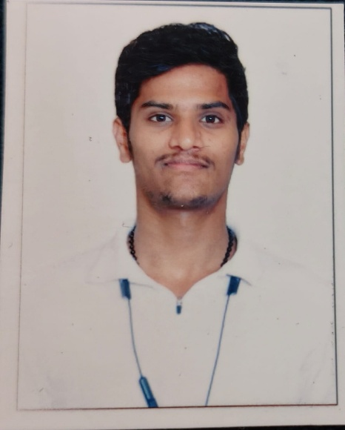 | 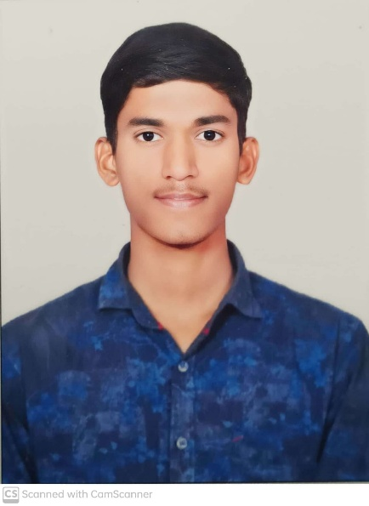 | 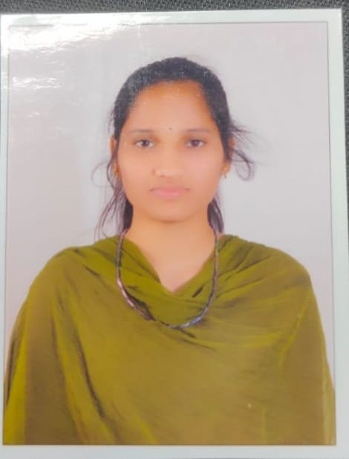
Name: G. Sai Kumar  Roll No: 22TQ1A0513  Mail: 22tq1a0513@siddhartha.co.in  Mobile: 9908172685  Sign: saikumar | Name: K. Siddhu  Roll No: 22TQ1A0534  Mail: 22tq1a0534@siddhartha.co.in  Mobile: 8341930313  Sign: siddhu | Name: B. Divya  Roll No: 23TQ5A0505  Mail: 23tq5a0505@siddhartha.co.in  Mobile: 8309751897  Sign: divya
BY

Guide Head of the department
Dr B. Anil Mr. A. Veerender
Department of CSE Department of CSE

